**REACT COURSE**

T Sree Sowmya

221910304044

Gitam Hyd CSE

**DAY-2 01/12/2022**

**LEARNIGS:**

* React is generally used to build Single Page Applications ,navigations are seen within the same page(it won’t redirect to new page).
* React is used in : Whatsapp web, Netflix,Myntra, Facebook

The created React-app (sowmya4044) contains folders:

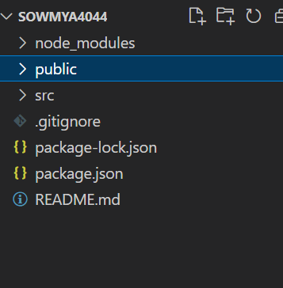

**src folder** has different sub .js files ,

2 important .js files are : index.js and App.js

**Index.js**: the first file to load during execution.

index file should import the .js files inorder to execute them.

REACT APP 🡪 src

**App.js:** default executing .js file . (used for displaying , printing statements)

1. Create a file called Gitam.js, in that file write the sentence “GITAM UNIVERSITY IS LOCATED IN HYDERABAD”. Execute the file Gitam.js by importing into “index.js”

Create gitam.js file….

Do: import🡪index.js

Export 🡪gitam.js

**syntax:** export default “filename” ---🡪export default gitam

import

**Code gitam.js file:**

import logo from './logo.svg';

//import './App.css';

function Gitam() {

  return (

    <div className="Gitam">

      <center><p> GITAM IS LOCATED IN HYEDERABAD-221910304044</p></center>

    </div>

  );

}

export default Gitam;

**code index.js file:**

in **index file** you should **import gitam file and** in render function **<Gitam/>**

import React from 'react';

import ReactDOM from 'react-dom/client';

import './index.css';

import App from './App';

import Scooter from './Scooter';

//import User from './User'; <App/>

//import Sowmya1 from './Sowmya1';

import Gitam from './Gitam';

import reportWebVitals from './reportWebVitals';

const root = ReactDOM.createRoot(document.getElementById('root'));

root.render(

  <React.StrictMode>

      <Gitam/>

  </React.StrictMode>

);

// If you want to start measuring performance in your app, pass a function

// to log results (for example: reportWebVitals(console.log))

// or send to an analytics endpoint. Learn more: https://bit.ly/CRA-vitals

reportWebVitals();

**Gitam.js :**

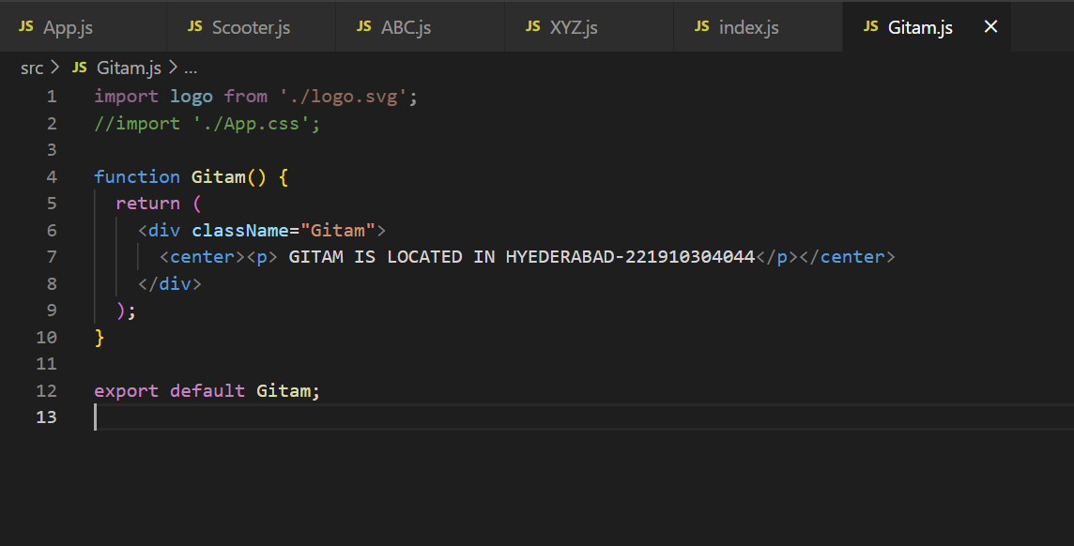

**Index.js:**

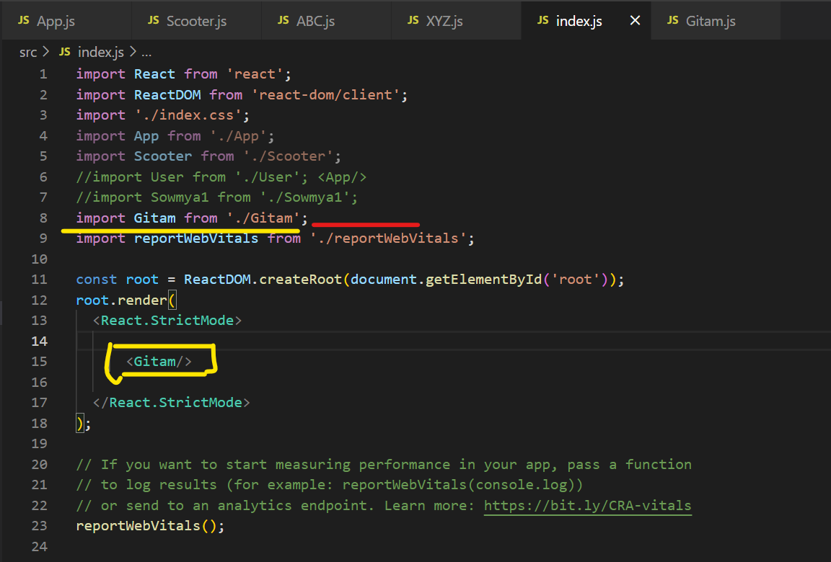

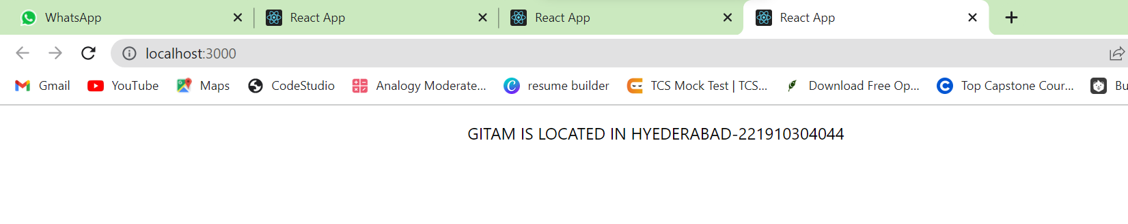Output:

**2) WRITE THE TEXT 3 TIMES WITHOUT LOOP**

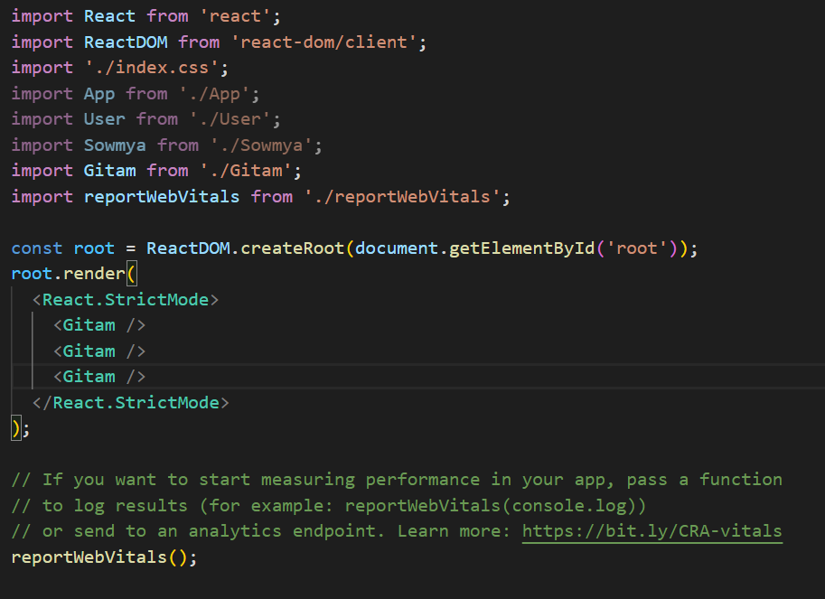

3) Create a file – “gitam.js”-🡪 import gitam.js in App.js, 🡪 import app.js in index.js

Create a file gitam.js and export gitam within file

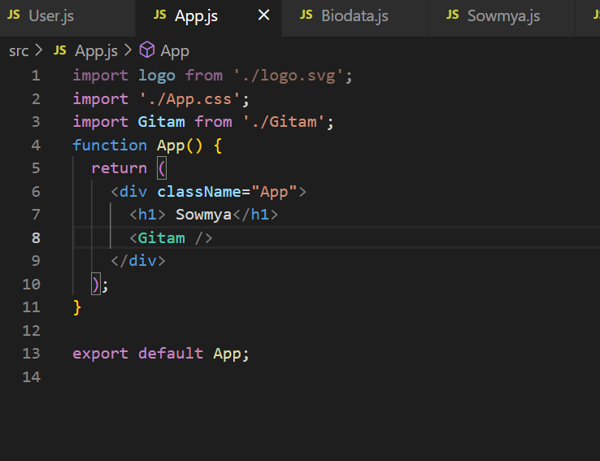

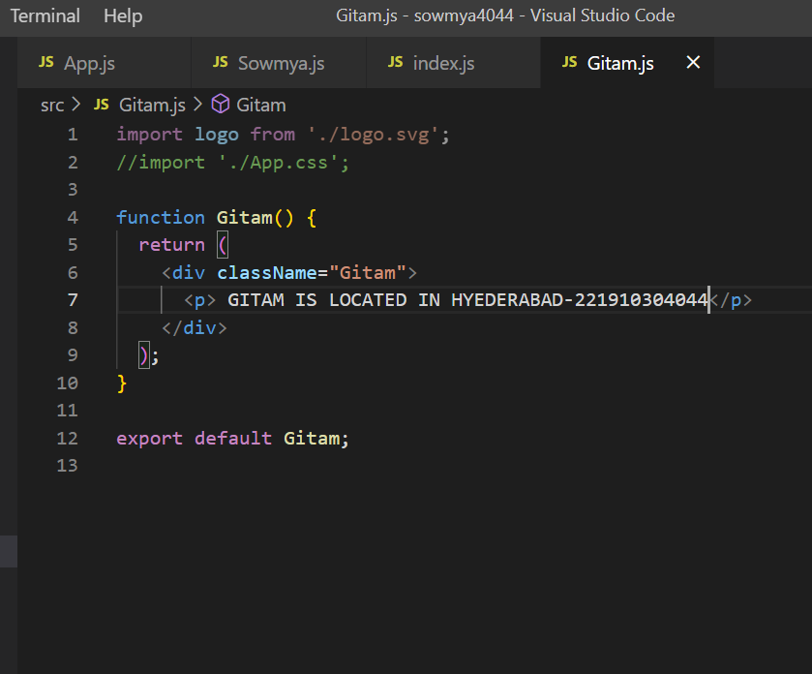

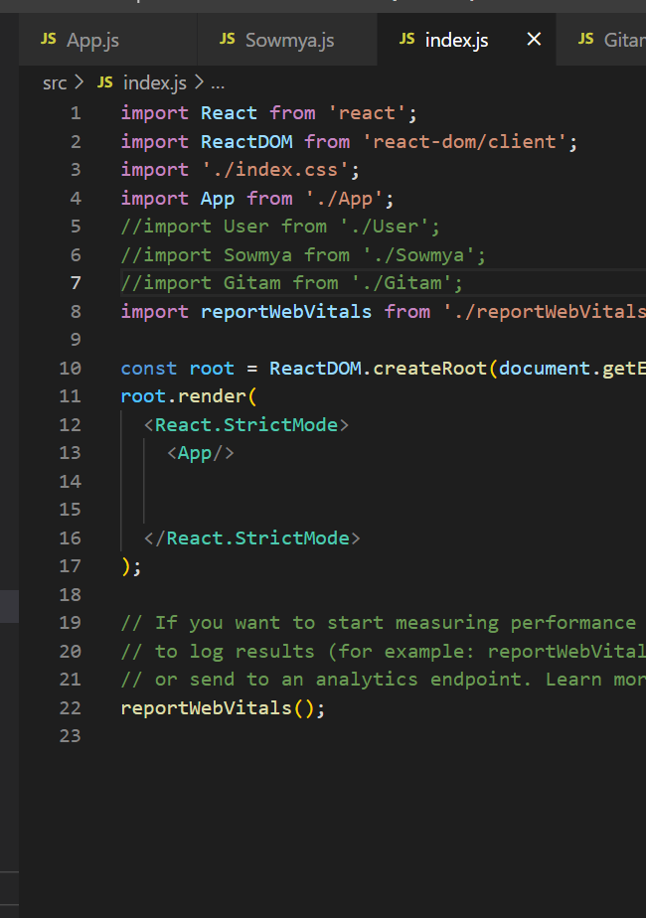

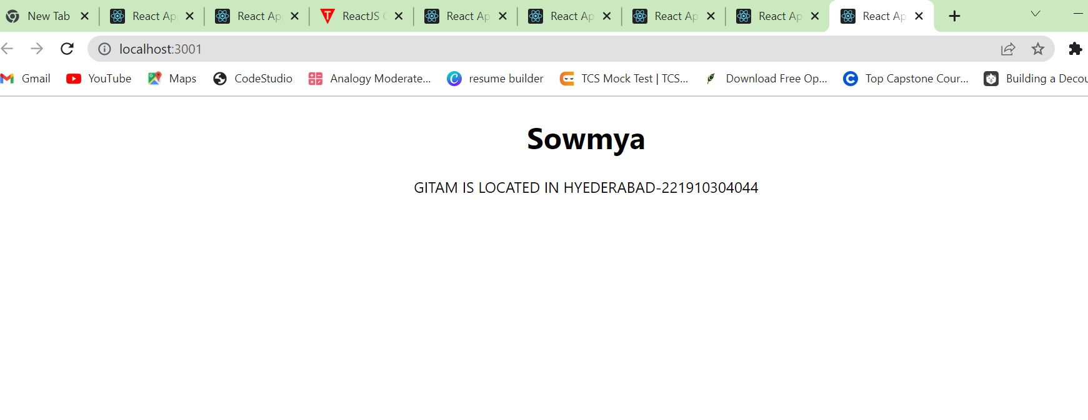

**3)** Create a file **ABC.JS print “ Virtusa,India,England” ,** create another file **XYZ.JS** print “**UNIVERSITY"**,”**SCHOOL**” AND THE CONTENTS OF ABC.JS , Take another file PQR.js print “fullname,and contents of XYZ.js” .Now, APP.js print “PIN num and Contents of PQR.js” .In INDEX.js file import APP.js and run Application

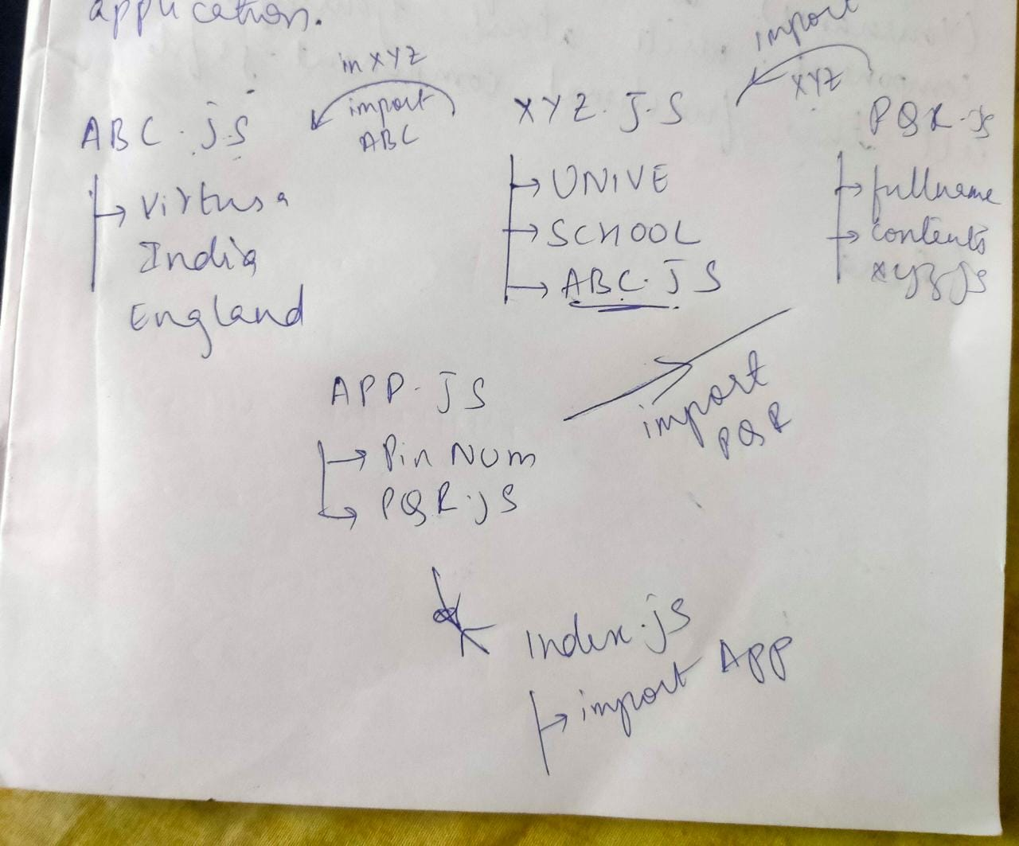

**Abc.js file:**

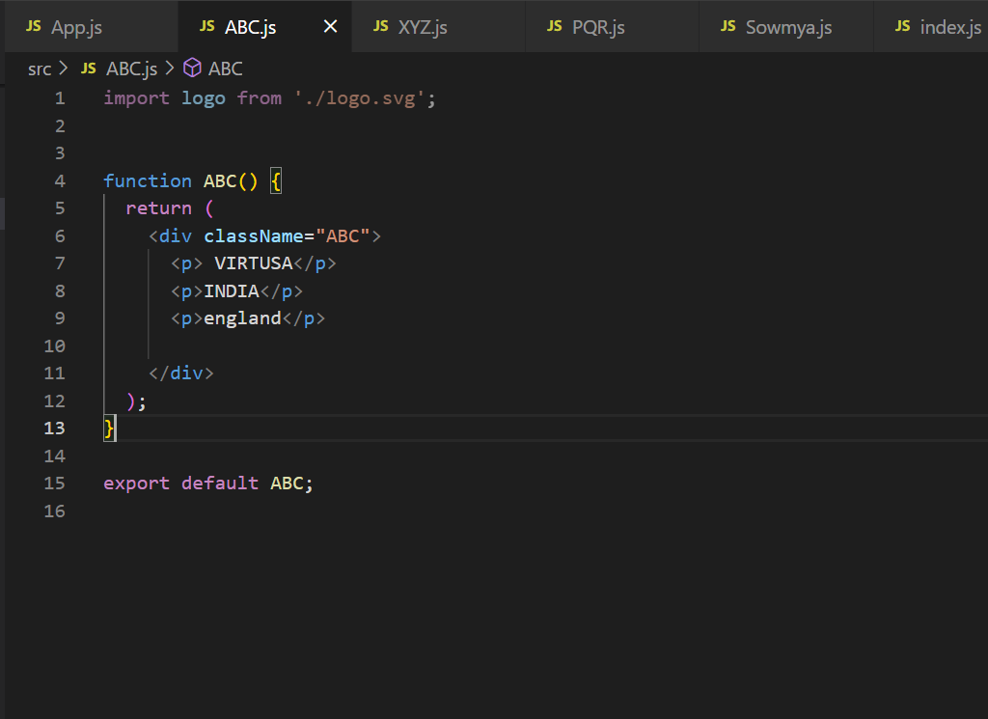

**XYZ.js:**

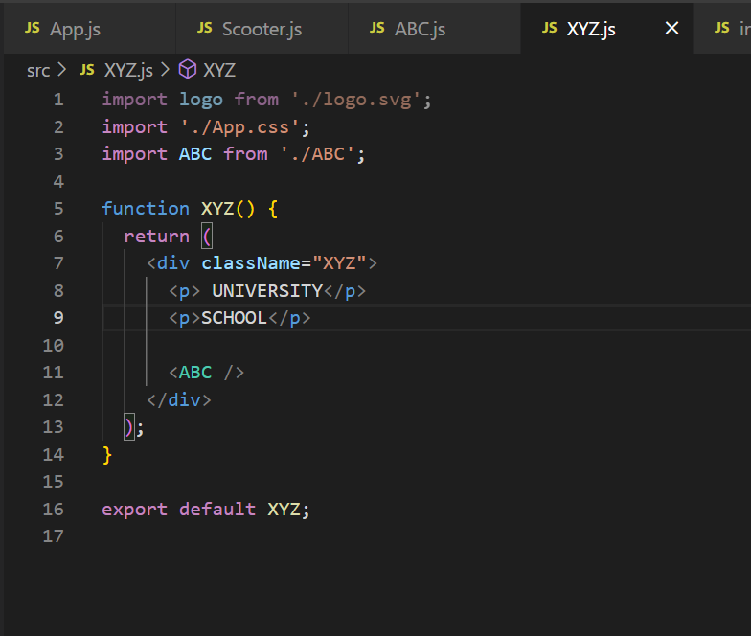

Pqr.JS:

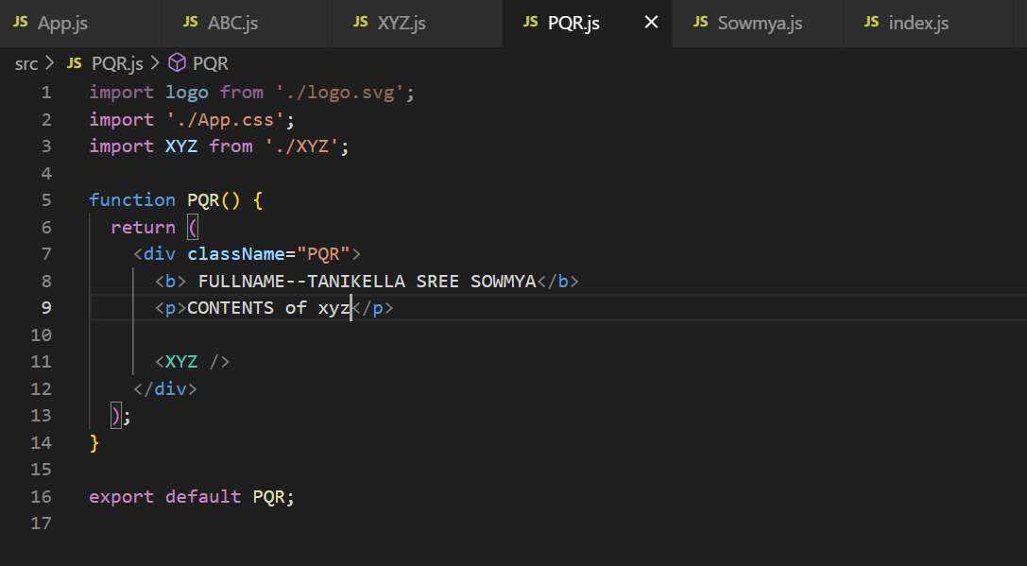

APP.JS:

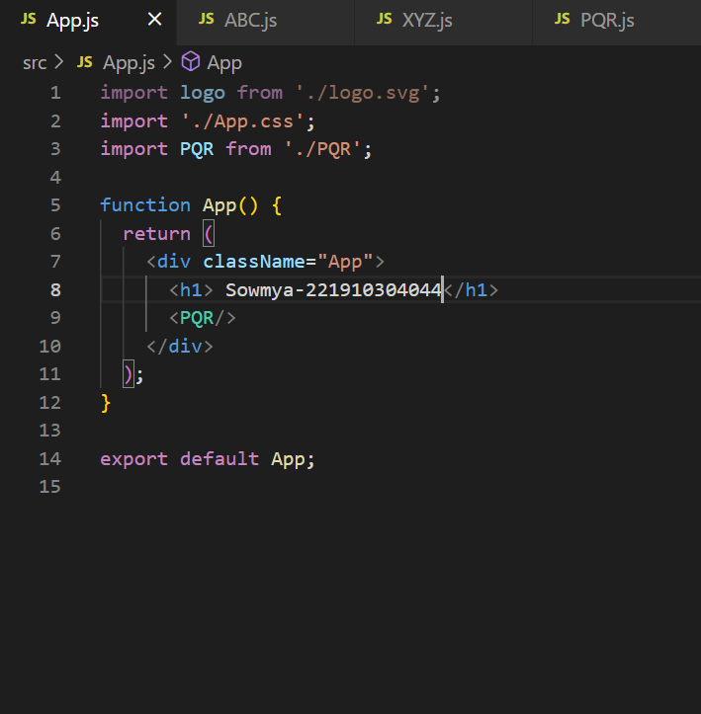

**INDEX.JS:**

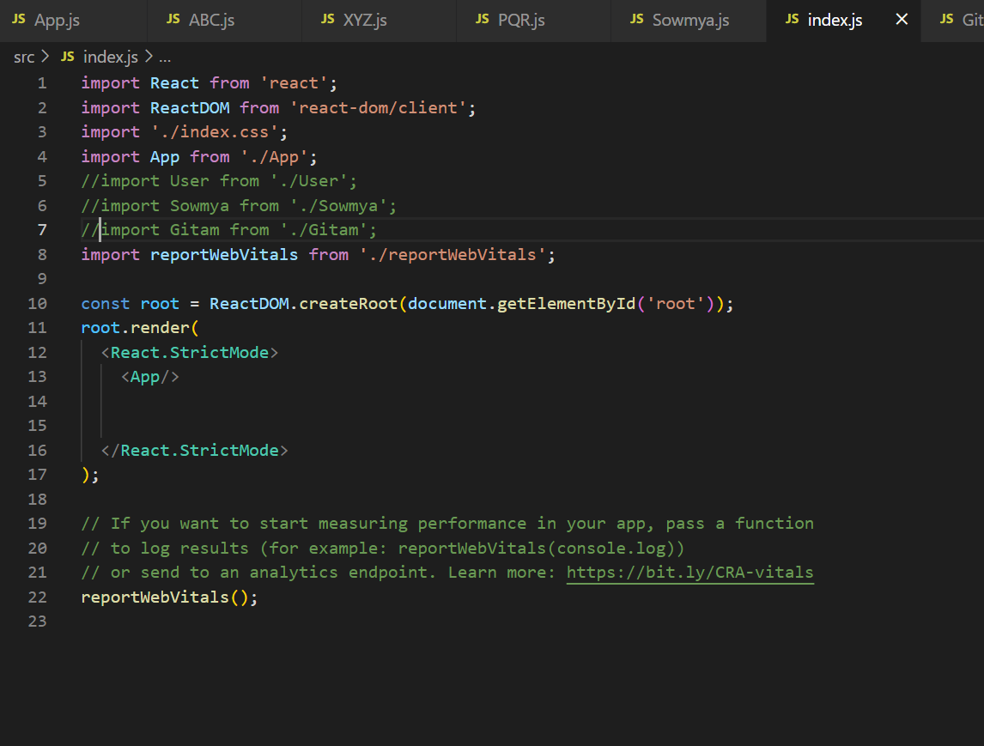

**OUTPUT:**

PRINTS ALL THE STATEMENTS

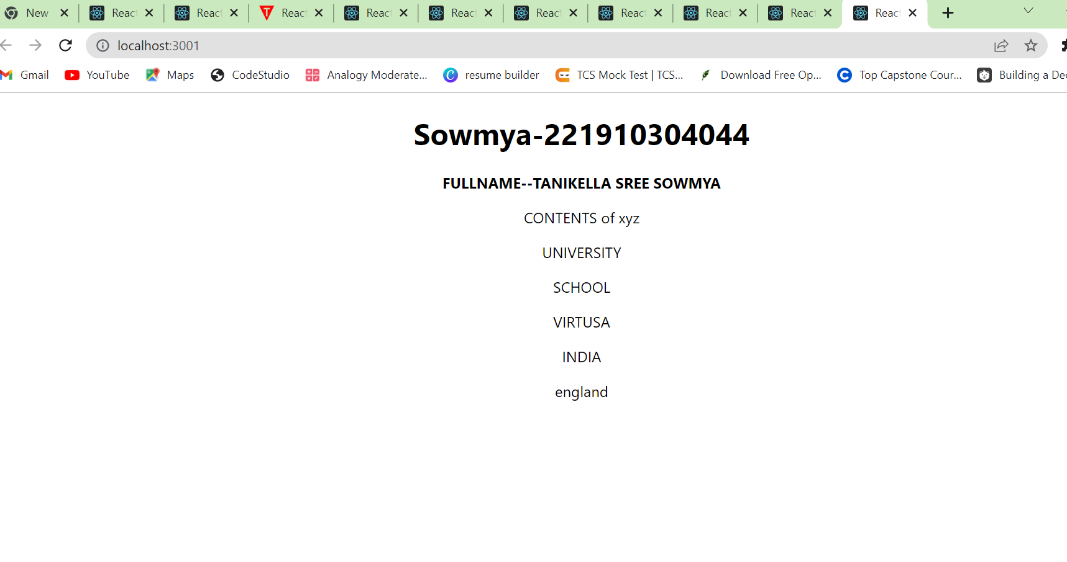

**DECLARING A FUNCTIONAL COMPONENT**

**Syntax:**

**Function Functionalname()**

**{**

**return (**

**//content**

**)**

**}**

4) Create a functional component (yourname) in that write your name, college, date-of -birth etc.,. And call this function component .js file

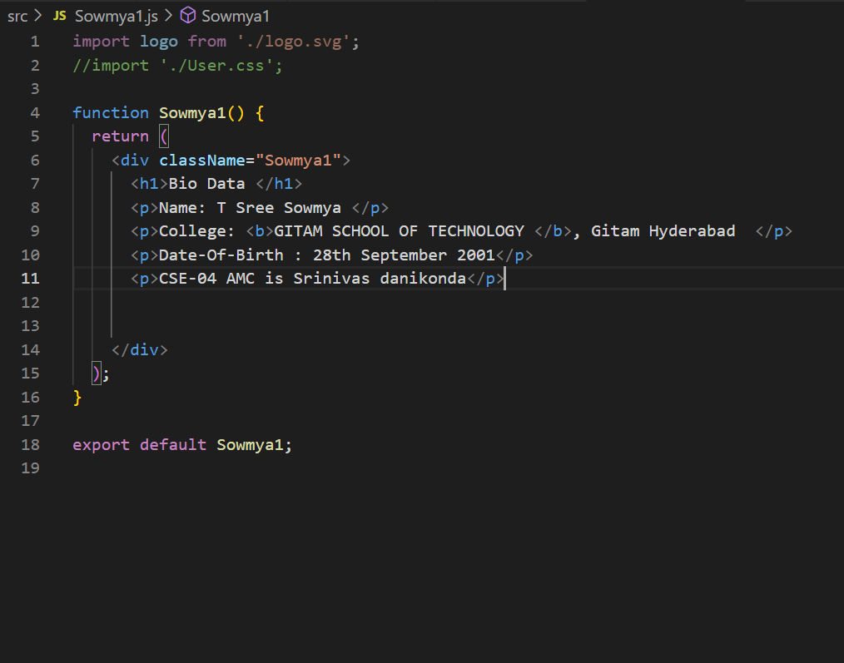

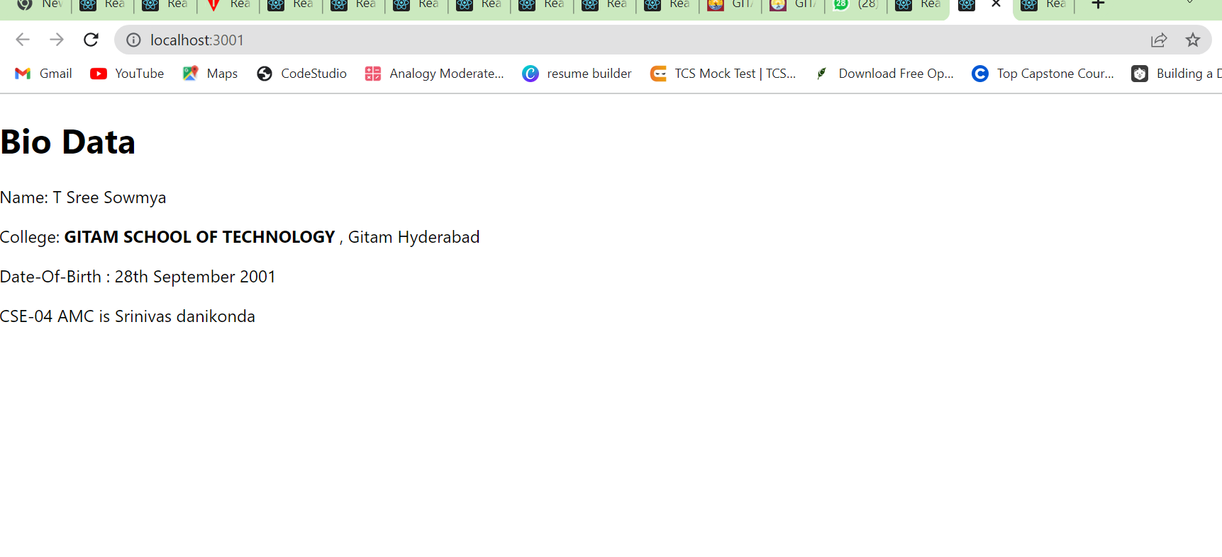

5)**Execution of sub functional compoent**

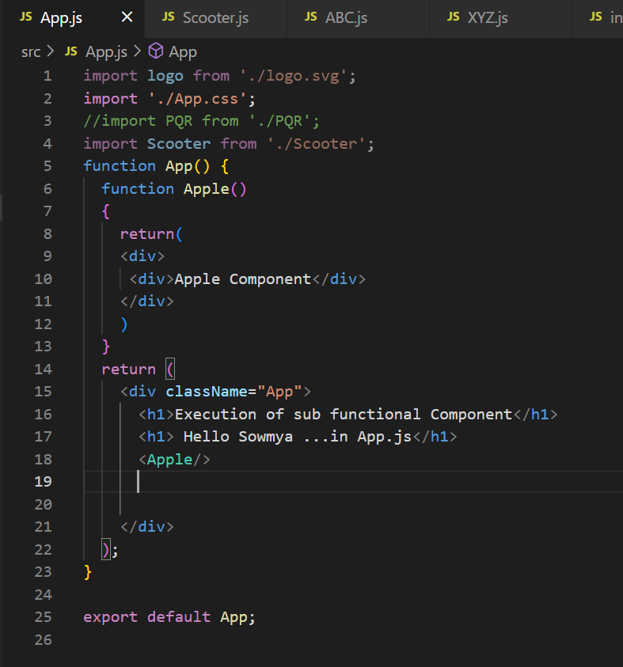

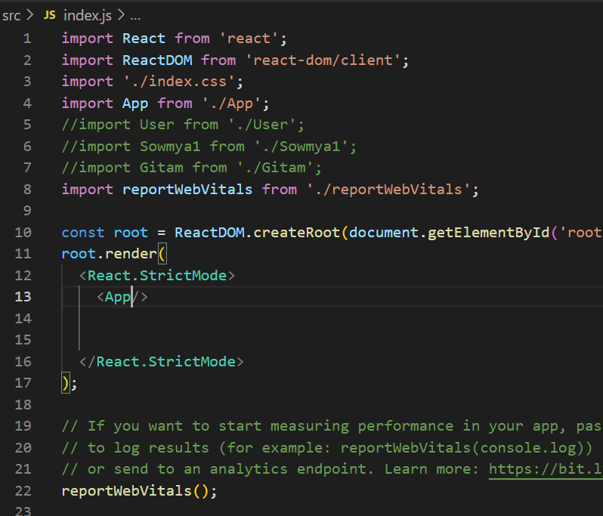

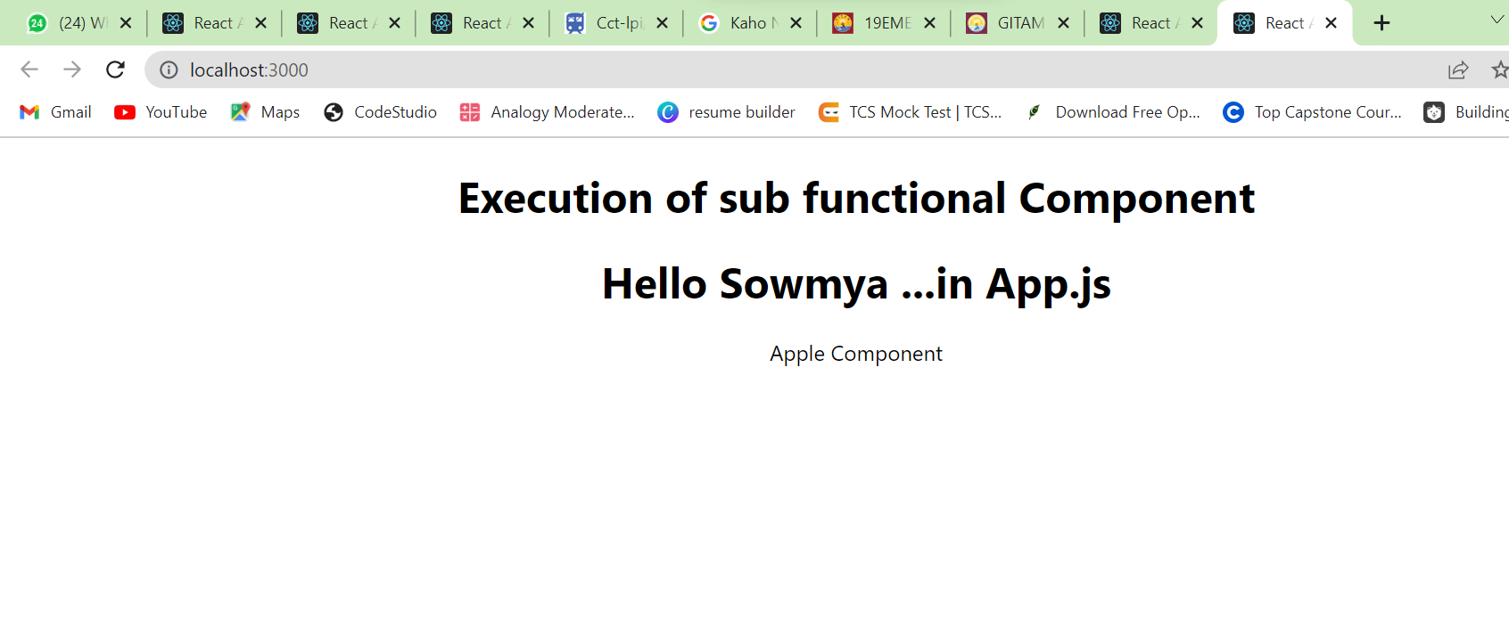

**6)app file 🡪sub function car(){print Suzuki} print “ application” in app file and import scooter**

**In Scooter file (user file) 🡪print chethak**

Index file “call app”

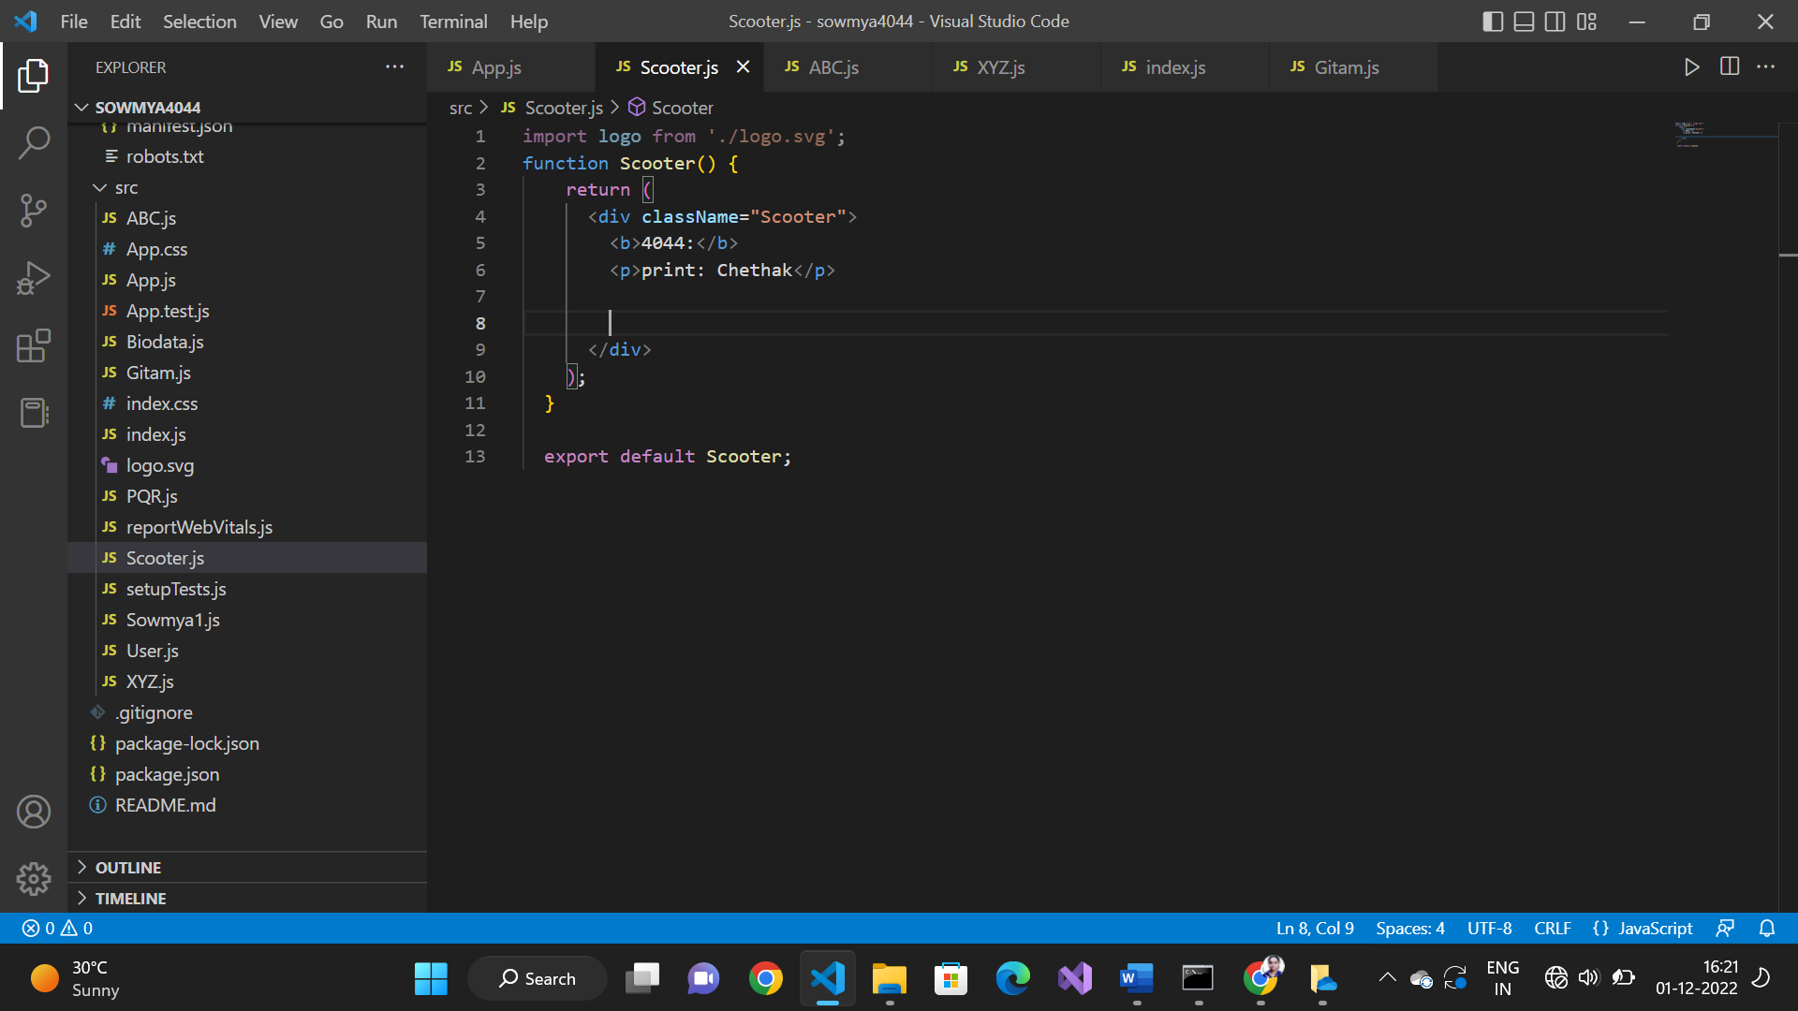

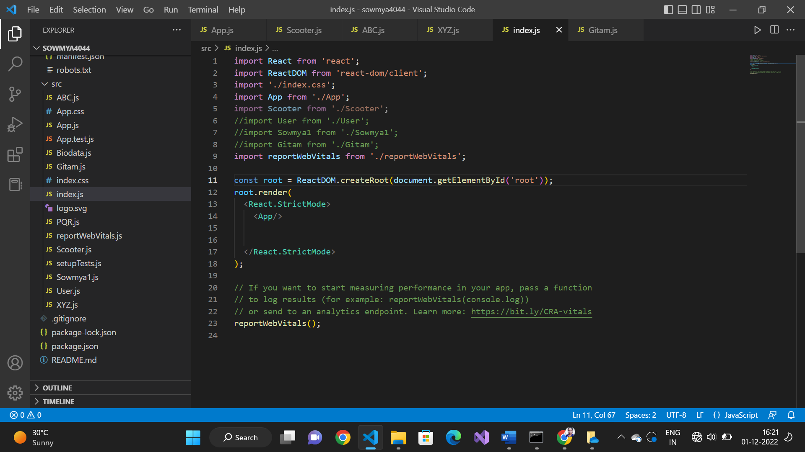

App file code:

import logo from './logo.svg';

import './App.css';

//import PQR from './PQR';

import Scooter from './Scooter';

function App() {

  function Car()

  {

    return(

    <div>

     <h1>Suzuki(sub function block)</h1>

    </div>

    )

  }

  return (

    <div className="App">

      <h1>Application</h1>

      <h1> Hello Sowmya ...in App.js</h1>

      <Car/>

      <Scooter/>

    </div>

  );

}

export default App;

